Interactive Chest Drainage System Educational Module
Knowledge Document + Codex Implementation Plan
Purpose: A clinician-facing, web-based interactive module that teaches pleural drainage physiology, historical and modern drainage systems, device knobology, digital drainage interpretation, and practical troubleshooting using case-based simulations. The content is educational and should be reviewed against local policy, device-specific instructions for use, and specialty society guidance before publication.
Core output | What it includes
Knowledge base | System types, pressure physiology, tube selection, suction/water-seal concepts, digital drainage, removal criteria, complications, and troubleshooting.
Interactive module blueprint | Screen-level plan, simulator data model, scenario library, assessment design, accessibility approach, and implementation milestones.
Codex-ready plan | Repo tasks, TypeScript data structures, prompts, tests, deployment checklist, and clinical review workflow.
Prepared for web implementation with a React/Next.js + TypeScript default stack; adaptable to other frameworks.

Table of Contents
- 1. Executive summary and educational thesis
- 2. Source review and evidence synthesis
- 3. Core knowledge for the module
- 4. Knobology: what users should be able to manipulate
- 5. Troubleshooting framework and case library
- 6. Interactive learning design
- 7. Codex implementation plan
- 8. Clinical QA, accessibility, and governance
- 9. Codex prompt pack
- 10. References

1. Executive summary and educational thesis
The module should teach chest drainage as a pressure-management system rather than as a “box with tubes.” A learner should be able to predict what happens when pleural pressure changes, when fluid accumulates, when a tube is kinked, when wall suction is altered, and when a digital system reports a flow trend.
- A safe drainage system does four things: lets air/fluid leave the pleural space, prevents retrograde flow, maintains or restores appropriate pleural pressure, and provides interpretable feedback.
- The visual language should be system-agnostic: one-bottle, two-bottle, three-bottle, integrated wet/dry analog units, Heimlich/Pneumostat-style ambulatory valves, and digital drainage should be presented as variations of the same physiologic circuit.
- “Knobology” should be interactive. Learners should physically fill a water seal, set a dry suction dial, increase/decrease source suction, toggle gravity drainage, interpret air-leak meters, and respond to digital alarms.
- Troubleshooting should always start with patient assessment, then progress from tube to drainage unit to suction source to disease physiology. The simulation should penalize actions that are unsafe in context, such as clamping a tube with an active air leak.
High-yield module idea: “The Box Is Not the Patient.” Every case begins with the patient; the device is interpreted in light of the clinical state, imaging, and the indication for drainage.
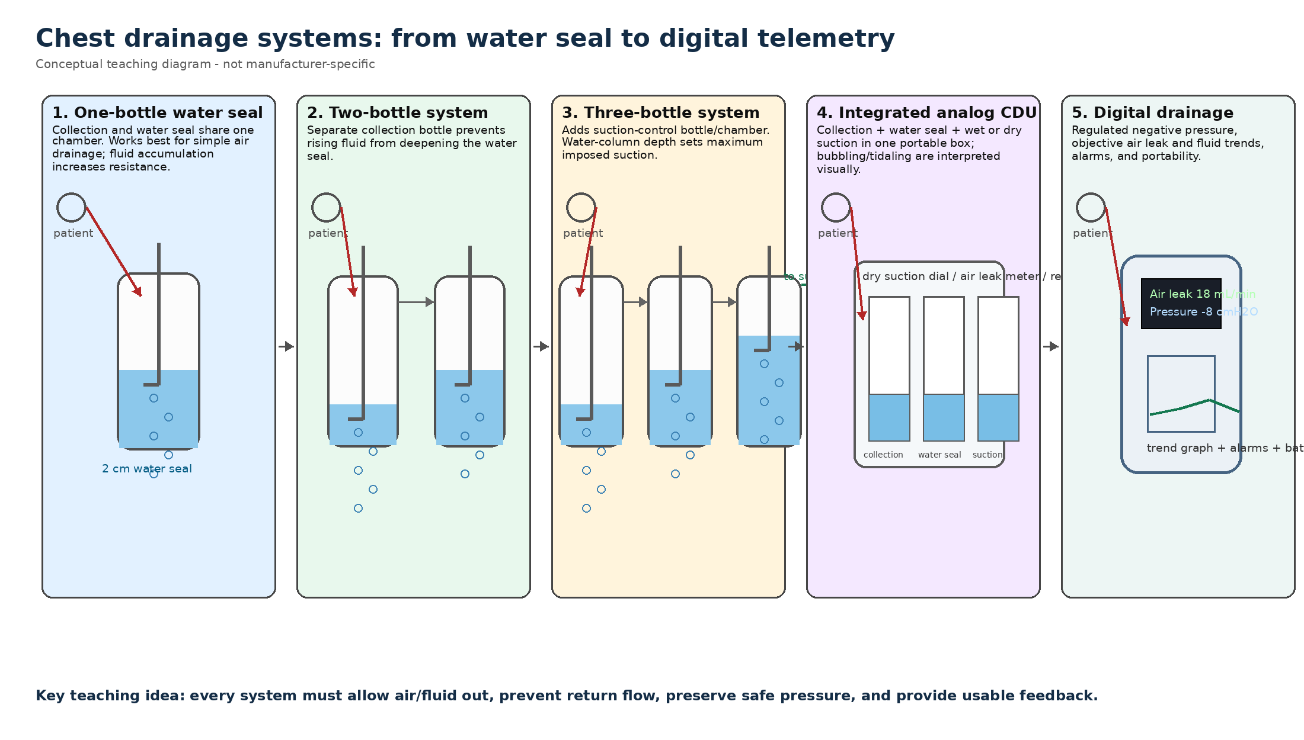
Figure 1. System evolution diagram for the module. Recreated conceptually for teaching; do not reuse manufacturer artwork without permission.

2. Source review and evidence synthesis
The uploaded articles provide a strong evidence base for the knowledge side of the module. I recommend organizing the source material into six anchor themes.
Source theme | Primary takeaways for the module | Interactive translation | Representative sources
System evolution | One-bottle systems combine collection and water seal; two-bottle systems separate collection; three-bottle systems add suction control; modern analog systems integrate these chambers. | Animated bottle laboratory with arrows, bubbling, water levels, and pressure readout. | Zisis 2015; Sorino 2024; textbook chapter
Wet vs dry suction | Wet suction is governed by water-column height; wall regulator values do not directly define patient suction. Dry suction uses a regulator/dial and indicators but may sacrifice some analog assessment cues. | Learner changes water-column depth or dry dial; simulator shows imposed suction and possible evaporation/over-bubbling effects. | Zisis 2015; Teleflex setup guide; Sorino 2024
Digital systems | Digital drainage offers regulated pressure, objective air-leak readings in mL/min, trends, alarms, and mobility, but device algorithms and capabilities vary. | Digital cockpit with flow trend, pressure trace, battery/canister/tubing alarms, and removal-threshold decisions. | George 2016; Ferrari 2025; Medela materials
Device design matters | Bench testing found heterogeneous performance among wet, dry, and hybrid devices, including reverse airflow, pressure-relief differences, and flow restrictions. | Comparison mode: same patient state connected to different generic device designs. | Antonicelli 2022
Clinical pathways | Tube size, suction strategy, removal thresholds, pleural infection drainage, and trauma drainage require context-specific choices. | Case library with indication-specific decisions and escalation paths. | Ferrari 2025; BTS 2023; ERS/EACTS/ESTS 2024; STS 2024
Procedure and complications | Ultrasound guidance, site selection, securement, malposition, occlusion, infection, bleeding, and re-expansion pulmonary edema are key safety topics. | Procedure-safety mini-module and troubleshooting cases. | Sorino 2024; textbook chapter

3. Core knowledge for the module

3.1 Pleural physiology to teach
- Normal pleural pressure is subatmospheric and changes during the respiratory cycle. The simulator should show respiratory swings, with the polarity reversed in positive-pressure ventilation.
- Air leaves the pleural space only when pleural/tube-side pressure overcomes the one-way seal or regulator threshold. Air must not be able to return into the pleural space.
- Fluid drainage is driven by gravity and pressure gradient, but tube radius, viscosity, kinking, dependent loops, and loculation strongly influence flow.
- A water seal is both a one-way valve and a clinical display. Bubbling, tidaling, and water-column movement are signals that must be interpreted in context.
- Suction can help evacuate air/fluid or overcome inadequate expansion, but indiscriminate suction can increase airflow through a visceral pleural defect, prolong some leaks, or contribute to re-expansion complications.

3.2 Drainage systems

One-bottle water seal
The same bottle collects drainage and provides the seal. It is conceptually simple and useful for teaching the one-way valve principle, but fluid accumulation increases the depth that air must overcome, making it less suitable when large fluid volumes are expected.

Two-bottle system
Separates collection from the water seal. This keeps the water seal depth stable even as pleural fluid drains.

Three-bottle system
Adds suction control. In a wet system, the suction-control water-column depth determines the maximum imposed suction, not the wall gauge.

Integrated analog CDU
Combines collection, water seal, suction control, positive pressure relief, high negativity relief, air leak meter, and patient tubing in one portable unit.

Dry suction / dry seal designs
Dry suction replaces the wet suction-control chamber with a self-compensating regulator and dial. Some dry-seal devices use one-way mechanical valves; learners must understand which chamber still contains water for air leak detection, if any.

Digital drainage
Digital systems regulate pressure near the patient and display objective air leak, fluid output, pressure/trend history, and alarms. They can reduce interobserver variability but should be taught as tools that support—not replace—clinical judgment.

Ambulatory one-way valves
Heimlich- or Pneumostat-style valves allow outpatient management of selected air leaks/pneumothoraces. The module should teach orientation, collection limitations, and red flags.

3.3 Tube/catheter selection concepts
The module should teach the “smallest effective caliber” principle while showing why high-viscosity or coagulating material can defeat small catheters. The tube-size lesson should make learners predict the effect of radius, viscosity, pressure gradient, and occlusion.
Clinical context | Default teaching point | When to escalate/adjust | Simulator variable
Simple pneumothorax | Small-bore catheter is usually adequate. | Large leak, failure to expand, mechanical ventilation/barotrauma, local policy. | airLeakSeverity, ventilationMode, tubeRadius
Pleural infection/empyema | Small-bore image-guided drain can work, especially with flushing and adjuncts. | Thick pus, loculations, failure of drainage, organized empyema -> fibrinolytics/medical thoracoscopy/VATS. | fluidViscosity, loculations, patency
Hemothorax/trauma | Traditional large-bore approach remains important; selected stable patients may use small-bore with protocol and surveillance. | Massive hemothorax, clot burden, retained hemothorax, hemodynamic instability. | bloodVolume, clotRisk, outputRate
Postoperative lung resection | Single drain and early removal pathways are increasingly common in defined contexts. | Complex resections, bloody output risk, large air leak, incomplete expansion. | drainCount, leakTrend, fluidTrend
Malignant pleural effusion | Drainage, talc pleurodesis, or indwelling pleural catheter depends on lung expandability, symptoms, goals, and logistics. | Non-expandable lung, recurrent symptoms, poor pleurodesis candidacy. | expandableLung, symptomScore, drainageGoal
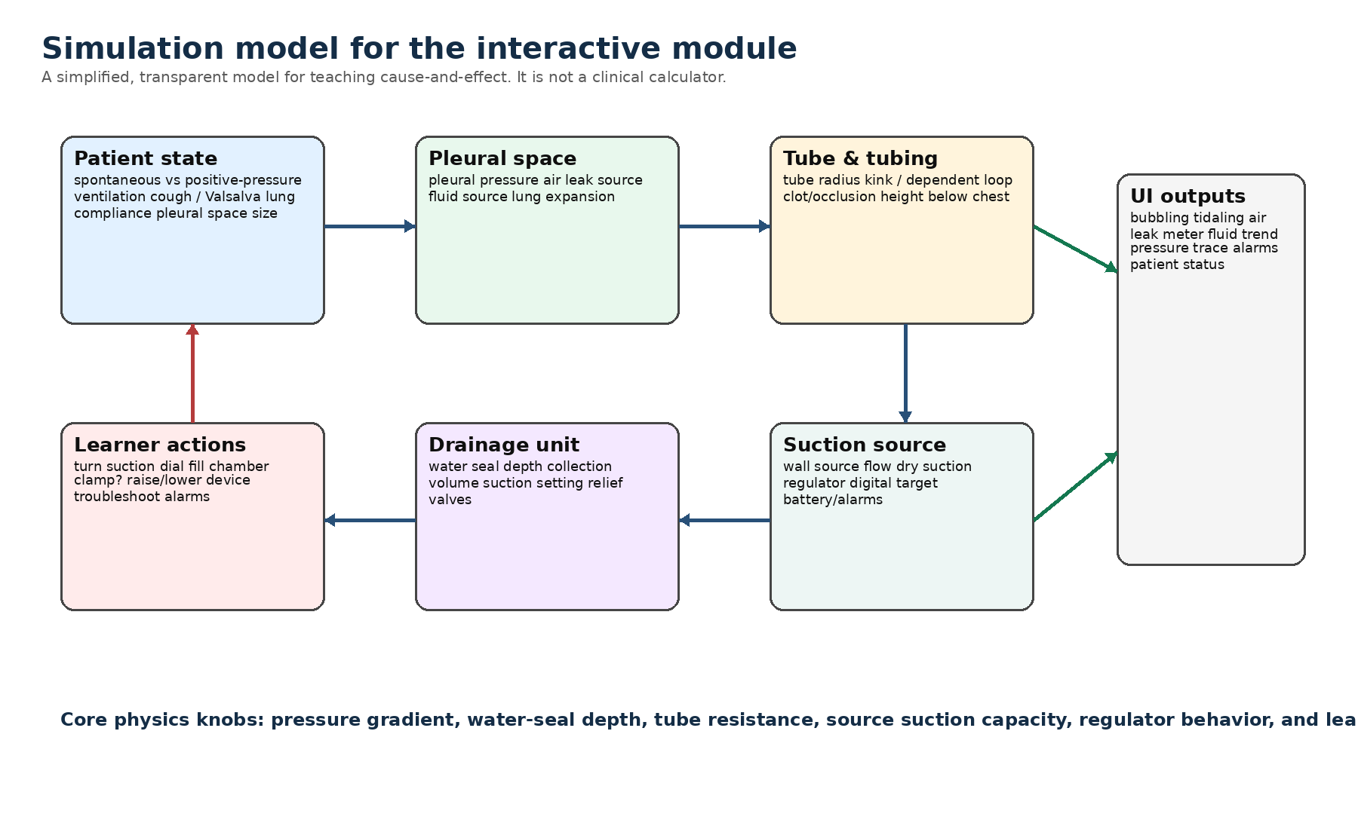
Figure 2. Proposed simulation state model. Keep equations simple, transparent, and clearly educational.

4. Knobology: what users should be able to manipulate
The module should include a “knobology lab” for generic analog and digital systems. The learner should be able to manipulate controls and immediately see clinical and mechanical consequences.
Control or observable | Wet analog unit | Dry analog unit | Digital unit | Teaching consequence
Water seal fill | Fill to manufacturer line; commonly 2 cm in classic water-seal teaching. | May have optional air-leak meter rather than true seal. | No water seal in most digital dry systems. | Too low loses seal; too high increases resistance.
Suction control | Fill suction chamber to prescribed cm H2O; apply wall suction until gentle bubbling. | Set dial to prescribed setting; increase source suction until indicator confirms. | Set prescribed target pressure; pump applies vacuum only as needed. | Shows why wall regulator is not the same as patient suction.
Wall source suction | More source suction increases airflow/noise/evaporation in wet systems, not prescribed patient suction. | Needed for indicator/regulator; excessive source usually regulated. | Usually independent battery/electric pump. | Avoid equating wall gauge with intrapleural pressure.
Air leak meter | Bubbling in water seal or calibrated columns. | Air leak meter may need fluid fill; water used only for detection in some dry-seal units. | Displayed as mL/min with trend graph. | Trend matters more than a single snapshot.
Tidaling/swing | Water level rises/falls with pleural pressure swings; direction depends on ventilation mode. | May be limited/absent depending on design. | Pressure traces may be visible or downloadable depending on device. | No tidaling can mean occlusion, malposition, lung expansion, or system-specific limitation.
High negativity relief | Manual/automatic depending on unit; use cautiously. | Manual/automatic depending on unit. | Managed by software/valves; alarms may display. | Teach when excessive negative pressure occurs and how relief can also reduce system negativity.
Gravity drainage | Keep unit below chest; suction off/open as prescribed. | Suction port instructions vary by device; keep unobstructed if gravity drainage. | Set to low-pressure/seal mode only according to device and order. | Height, loops, and backflow risks are visible.
Canister/output reset | Manual marking with time/date. | Manual marking with time/date. | Fluid reset/history button; canister recognition. | Output documentation and trend interpretation.
Alarms | Visual inspection only. | Visual indicators; some relief valves. | Occlusion, disconnection, suction failure, battery, canister. | Digital alarms require an algorithmic response, not blind reset.

4.1 Knobology mini-lessons

Wet suction chamber
- Fill to the prescribed water-column depth.
- Attach wall suction and adjust until gentle bubbling occurs.
- Increasing wall suction beyond gentle bubbling generally increases airflow/noise and evaporation rather than patient suction.

Dry suction dial
- Rotate the dial to the ordered setting.
- Increase source suction until the suction indicator appears.
- If decreasing from higher to lower suction, residual negativity may require high-negativity relief depending on device and policy.

Digital system
- Check battery, seal, tubing, canister size, and functional test.
- Turn on and verify self-test before patient connection when required by IFU.
- Interpret mL/min flow and pressure trend over time; do not overreact to one transient breath/cough.

5. Troubleshooting framework and case library
The troubleshooting trainer should use a standardized mental model: patient first, then tube, unit, suction, disease physiology, and reassessment. Each case should include a wrong but tempting action and a safer alternative.
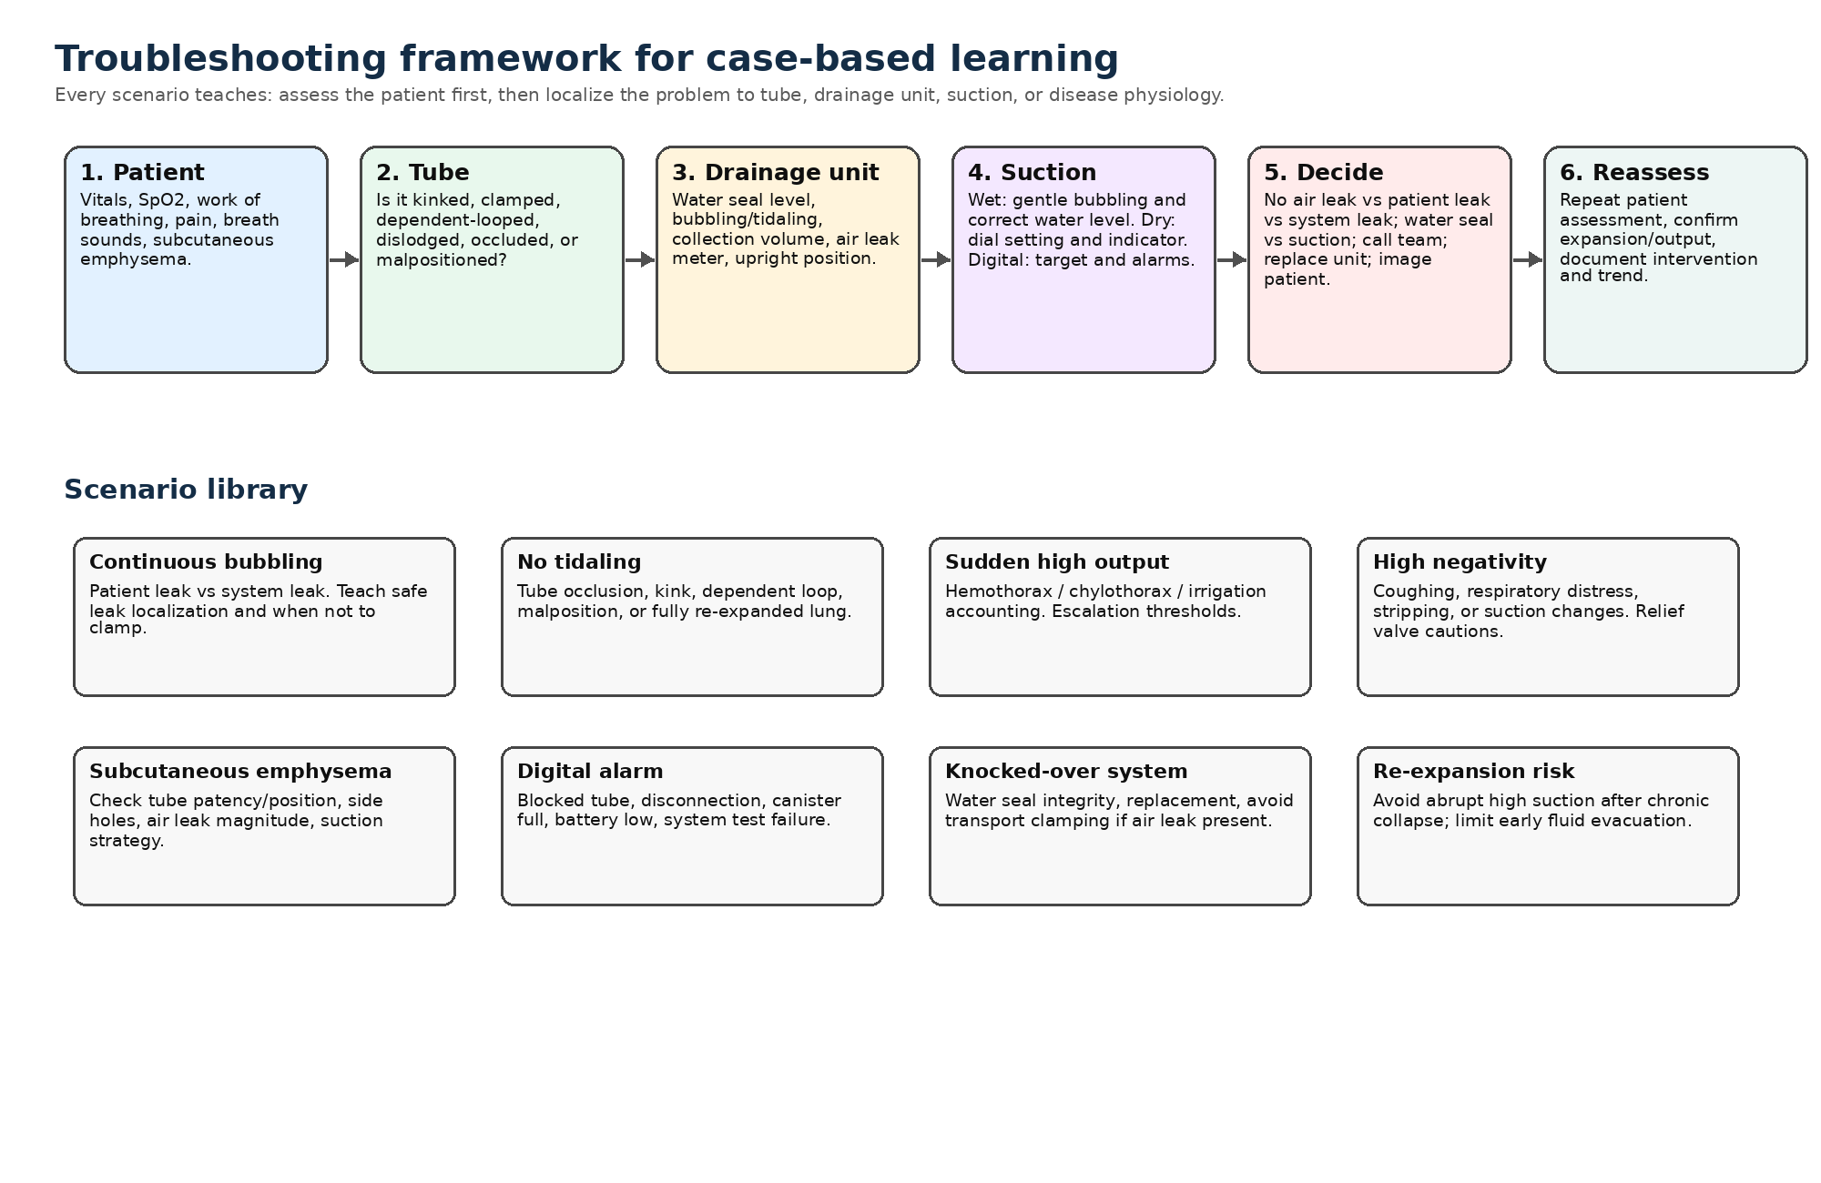
Figure 3. Troubleshooting framework and scenario library.
Scenario | Learner sees | Correct reasoning | Simulation feedback
Continuous bubbling | Persistent bubbling in water seal or high digital flow. | Differentiate patient air leak from system leak; inspect connections; avoid clamping if there is a known active patient leak except under protocol/supervision. | Tension pneumothorax risk rises if learner clamps a tube with ongoing leak.
No tidaling | No water-column swing; patient stable or dyspneic. | Consider occlusion/kink/dependent loop, malposition, lung re-expansion, or system design/positive-pressure ventilation. | If kink relieved, flow returns; if lung expanded, stable no tidaling is acceptable.
Drainage system knocked over | Water seal level compromised and device no longer upright. | Restore closed system; replace unit if seal compromised; clamp only briefly if no air leak and policy allows. | Air can enter if water seal lost; active leak worsens if clamped.
High negative pressure | Water column rises; patient coughing or tube stripped. | Stop stripping/milking, assess patient, use relief valve only according to policy and system state. | Mediastinal/pleural trauma risk meter rises with aggressive stripping.
Dry suction indicator absent | Dial is set but orange float/indicator absent. | Check source suction connection, source flow, tubing occlusion, and prescribed setting. | Indicator appears only when source flow is sufficient.
Digital blocked-tube alarm | Alarm, rising pressure/flow change, low output. | Assess patient, inspect tube and canister, straighten kinks, follow IFU for catheter check. | Alarm resolves after correcting obstruction; unsafe reset produces recurrence.
Subcutaneous emphysema | Increasing crepitus with persistent leak. | Assess tube position/side holes, patency, leak size, suction strategy, and need for escalation. | Subcutaneous air decreases only when leak evacuation exceeds leak generation.
Re-expansion risk | Large chronic pneumothorax or large effusion; suction requested. | Avoid abrupt high suction; staged drainage and monitoring reduce risk. | Rapid re-expansion raises edema risk meter.

6. Interactive learning design

6.1 Audience and learning objectives
Primary audience: residents/fellows, APPs, nurses, respiratory therapists, ICU clinicians, thoracic surgery/pulmonary trainees, and proceduralists who manage pleural drainage. Advanced mode can include device-performance nuances for interventional pulmonology and thoracic surgery audiences.
- Explain the one-way valve principle and the purpose of water seal, collection, and suction-control chambers.
- Predict how water level, gravity height, source suction, regulator settings, and air leak severity affect flow and pressure.
- Set up and interpret a generic wet suction, dry suction/dry seal, Heimlich/Pneumostat-style, and digital drainage system.
- Distinguish normal tidaling from concerning patterns and differentiate patient air leak from system leak.
- Apply a safe troubleshooting sequence to bubbling, no tidaling, occlusion, high output, disconnection, high negativity, and digital alarms.
- Choose evidence-consistent drainage strategies and removal criteria by indication, with emphasis on local protocols and manufacturer IFUs.

6.2 Module map
Unit | Title | Interaction | Assessment | Estimated time
1 | Pressure and pleural space | Drag pleural pressure slider; toggle spontaneous/PPV; see tidaling direction. | 3 prediction checks | 10 min
2 | One-, two-, and three-bottle lab | Build systems by connecting bottles; fill water seal; add suction. | System assembly challenge | 15 min
3 | Analog CDU knobology | Generic integrated unit with collection, water seal, air leak meter, wet/dry suction controls. | Setup checklist | 15 min
4 | Digital drainage cockpit | Adjust target pressure; review mL/min trend, fluid history, alarms. | Removal threshold decisions | 15 min
5 | Ambulatory valves | Valve orientation, collection options, outpatient red flags. | Safe discharge quiz | 8 min
6 | Troubleshooting rounds | Timed patient cases with branching consequences. | Scenario score + debrief | 25 min
7 | Indication pathways | Pneumothorax, effusion, hemothorax, infection, postop, MPE. | Case-based pathway selection | 15 min
8 | Final assessment | Mixed cases + dashboard interpretation. | Certificate threshold optional | 15 min

6.3 Visual and UX requirements
- Use SVG for drainage systems so water levels, bubbles, arrows, and knobs can animate smoothly and remain responsive.
- Use a single simulation state store so every visual element is derived from the same patient/device model.
- Show both “what you see” and “what it means.” Example: water seal bubbling appears next to a callout explaining patient leak, system leak, or reverse airflow depending on state.
- Provide toggles for novice/advanced mode. Novice mode emphasizes chambers and safety; advanced mode adds pressure traces, device design, and flow-capacity nuance.
- Use “explain my mistake” feedback rather than simple right/wrong scoring.
- Avoid proprietary look-and-feel. Use generic device art unless assets are licensed or permission is obtained.

7. Codex implementation plan
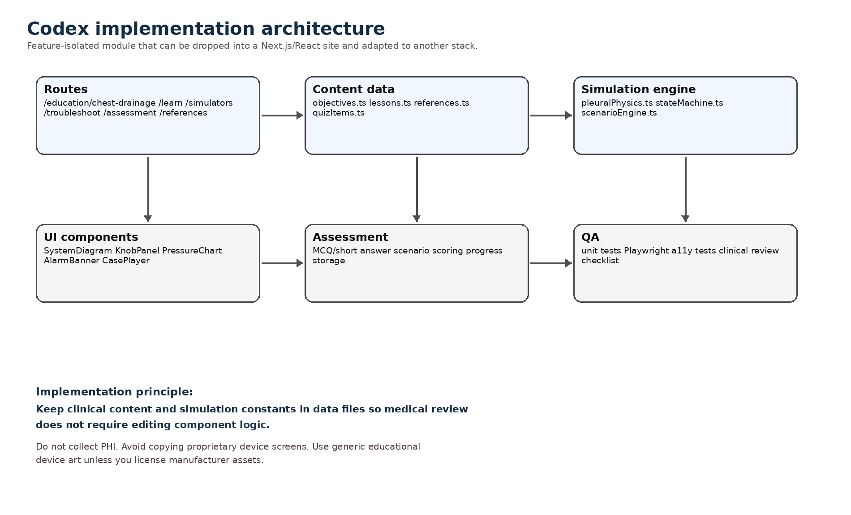
Figure 4. Suggested Codex implementation architecture.

7.1 Assumed stack
Default stack: Next.js App Router, React, TypeScript, SVG/Canvas animations, Zustand or React context for simulation state, Recharts or lightweight SVG for trends, MDX for static lessons, Vitest for unit tests, Playwright for E2E, and axe-core for accessibility checks. If your existing website is not Next.js, keep the content data model and simulation engine and port the UI components.

7.2 File structure
src/features/chest-drainage/
content/
lessons.ts
references.ts
quizItems.ts
glossary.ts
engine/
types.ts
constants.ts
pleuralPhysics.ts
scenarioEngine.ts
alarms.ts
components/
SystemDiagram.tsx
BottleSystemLab.tsx
AnalogCDULab.tsx
DigitalDrainCockpit.tsx
TroubleshootingCase.tsx
PressureTrendChart.tsx
KnobPanel.tsx
DebriefPanel.tsx
scenarios/
pneumothorax.ts
pleuralEffusion.ts
postOpAirLeak.ts
hemothorax.ts
pleuralInfection.ts
__tests__/
pleuralPhysics.test.ts
scenarioEngine.test.ts
app/education/chest-drainage/
page.tsx
learn/page.tsx
simulators/page.tsx
troubleshooting/page.tsx
assessment/page.tsx
references/page.tsx

7.3 Simulation data model
export type DrainageSystemType =
| 'oneBottleWaterSeal'
| 'twoBottleWaterSeal'
| 'threeBottleWetSuction'
| 'integratedWetSuction'
| 'integratedDrySuction'
| 'drySealDrySuction'
| 'digitalDrainage'
| 'heimlichValve';
export interface SimulationState {
systemType: DrainageSystemType;
patient: {
ventilation: 'spontaneous' | 'positivePressure';
lungCompliance: number; // 0-1 educational scale
pleuralPressureCmH2O: number;
airLeakSeverity: number; // 0-1
fluidProductionMlPerHr: number;
cough: boolean;
};
tube: {
frenchSize: number;
patency: number; // 0-1
kinked: boolean;
clamped: boolean;
dependentLoop: boolean;
sideHolesInChest: boolean;
};
device: {
waterSealDepthCm: number;
suctionSettingCmH2O: number;
sourceSuctionFlowLpm: number;
collectionVolumeMl: number;
upright: boolean;
heightBelowChestCm: number;
canisterFull: boolean;
batteryPct?: number;
};
}

7.4 Simplified teaching equations
Use equations only to support qualitative learning. Keep them visible in “advanced mode” so learners understand assumptions.
- tubeConductance = k * (internalRadius ^ 4) * patency / viscosityFactor
- effectiveSuctionWet = min(abs(suctionControlDepthCm), availableSourceCapacity)
- effectiveSuctionDry = clamp(targetSuction, capacityLimit, responseLag)
- expiratoryAirExit = max(pleuralPressure - waterSealDepth, 0) * tubeConductance
- digitalFlowDisplay = smoothed(trueAirLeakFlow + measurementNoise + transientCoughSpikes)
- riskReexpansionEdema increases with chronicCollapse + rapidExpansion + highNegativePressure

7.5 Sprint plan
Sprint | Build | Clinical review artifact | Definition of done
0: Repo discovery | Codex inspects repo, identifies framework, creates feature branch and route scaffold. | Architecture note. | No regressions; route renders placeholder.
1: Content + glossary | Static lessons, references, glossary, source notes. | Medical content table for review. | Content renders, citations listed, no PHI.
2: Simulation engine | State model, pressure/flow functions, test fixtures. | Assumption sheet. | Unit tests pass; states produce expected qualitative outputs.
3: Bottle lab | One-/two-/three-bottle SVG simulator. | Storyboard screenshots. | Learner can assemble and manipulate systems.
4: Analog knobology | Wet/dry suction dial, air leak meter, relief valve, water seal/tidaling animations. | Clinical safety review. | Controls produce correct feedback and warnings.
5: Digital cockpit | mL/min trend, pressure target, alarms, canister/battery states. | Digital interpretation checklist. | Trend-based removal cases function.
6: Troubleshooting cases | Branching cases and debriefs. | Case scripts. | At least 8 cases with scoring and safe/unsafe consequences.
7: Assessment + polish | Quiz, progress, accessibility, mobile layout. | Final reviewer packet. | WCAG checks pass; Playwright tests pass; deploy preview approved.

8. Clinical QA, accessibility, and governance

8.1 Clinical review checklist
- All clinical thresholds must be labeled as examples and tied to local policy/device IFU when used for practice.
- All device-specific setup steps must be generic unless the module explicitly identifies a licensed device and references its current IFU.
- Every unsafe action should trigger a debrief explaining why it is unsafe and what local protocols usually require.
- No module pathway should imply actual patient management without bedside assessment and clinician judgment.
- Review by at least one interventional pulmonologist/thoracic surgeon and one chest-tube-experienced nurse or RT before publication.

8.2 Web accessibility
- Target WCAG 2.2 AA. Provide keyboard control for every knob/slider, visible focus states, adequate target sizes, and non-drag alternatives.
- Provide text equivalents for all animations: “bubbling present,” “water seal depth 2 cm,” “current air leak 28 mL/min,” etc.
- Avoid relying on color alone; use labels, patterns, icons, and textual status messages.
- Respect reduced-motion preferences. Offer pause/step-through mode for animations.
- Make case debriefs screen-reader friendly and exportable as text.

8.3 Content governance
- Store clinical content in versioned data/MDX files with a “last reviewed” date and reviewer initials.
- Separate device-specific IFU content from general physiology so individual device pages can be updated without rewriting the module.
- Use analytics only for module performance, not patient care; do not collect PHI.
- Schedule annual guideline review and immediate review after major BTS/ACCP/ERS/STS/ERAS updates or device IFU changes.

9. Codex prompt pack
Use these prompts sequentially in Codex. Each prompt should be run after committing the prior step.

Prompt 1: Repo reconnaissance
Inspect this repository and identify the frontend framework, routing approach, styling system, test setup, and deployment constraints. Do not modify files. Return a concise implementation plan for adding a feature-isolated chest-drainage education module.

Prompt 2: Route scaffold
Create a feature branch and add a new route /education/chest-drainage with placeholder subpages: learn, simulators, troubleshooting, assessment, and references. Add navigation cards and ensure the route matches existing site styling. Do not add clinical content yet.

Prompt 3: Content data model
Add feature-local TypeScript content files for lessons, glossary, references, and quiz items. Populate with neutral placeholder data and types. Keep all clinical text in data files, not component logic.

Prompt 4: Simulation engine
Implement the SimulationState type, constants, and pure functions in engine/pleuralPhysics.ts. Include unit tests that verify: water seal prevents return flow, increasing water seal depth increases resistance, tube clamping stops flow, and dry suction target is bounded by source capacity.

Prompt 5: Bottle system simulator
Build an SVG BottleSystemLab component where learners can assemble one-, two-, and three-bottle systems, fill the water seal, add suction, and see arrows/bubbles/water levels update from SimulationState.

Prompt 6: Analog CDU lab
Build a generic integrated chest drainage unit simulator with collection chamber, water seal, air leak meter, wet/dry suction mode, suction indicator, high-negativity relief, and a control panel. Include safety warnings for unsafe clamping and compromised water seal.

Prompt 7: Digital cockpit
Build DigitalDrainCockpit with target pressure, air leak mL/min trend, fluid output trend, canister/battery/tubing alarms, and a debrief panel that explains trend-based decisions.

Prompt 8: Troubleshooting cases
Implement scenarioEngine.ts and at least eight branching cases: continuous bubbling, no tidaling, high output, high negativity, subcutaneous emphysema, digital blocked-tube alarm, knocked-over system, and re-expansion risk. Each case must include patient-first assessment and debrief.

Prompt 9: Assessment and accessibility
Add quiz and scenario scoring, keyboard control for all knobs, aria labels for dynamic indicators, prefers-reduced-motion handling, and axe-core checks. Add Playwright smoke tests for the main route and one simulator interaction.

Prompt 10: Clinical review mode
Add a reviewer page or export that lists all clinical statements, thresholds, references, and last-reviewed dates so medical reviewers can approve content without searching the component tree.

10. References and source notes
- Zisis C, et al. Chest drainage systems in use. Ann Transl Med. 2015;3(3):43. Uploaded PDF: atm-03-03-43.pdf.
- George RS, Papagiannopoulos K. Advances in chest drain management in thoracic disease. J Thorac Dis. 2016;8(Suppl 1):S55-S64. Uploaded PDF: jtd-08-S1-S55.pdf.
- Antonicelli A, et al. Chest Drainage Therapy: What Comes out of Pandora’s Box Can Affect Patient Outcomes. J Clin Med. 2022;11:5311. Uploaded PDF: jcm-11-05311.pdf.
- Sorino C, et al. Chest Tubes and Pleural Drainage: History and Current Status in Pleural Disease Management. J Clin Med. 2024;13:6331. Uploaded PDF: jcm-13-06331.pdf.
- Ferrari PA, et al. Comprehensive Overview of Current Pleural Drainage Practice: A Tactical Guide for Surgeons and Clinicians. Surgeries. 2025;6:108. Uploaded PDF: surgeries-06-00108.pdf.
- Boujaoude Z, Shersher D. Chest Tube Thoracostomy. Uploaded textbook chapter PDF: 3-s2.0-B9780323446761000157.pdf.
- British Thoracic Society. Pleural Disease guideline and Clinical Statement on Pleural Procedures. July 2023. https://www.brit-thoracic.org.uk/clinical-resources/guidelines/pleural-disease/
- Walker S, et al. Joint ERS/EACTS/ESTS clinical practice guidelines on adults with spontaneous pneumothorax. Eur Respir J. 2024;63:2300797.
- Kent MS, et al. Society of Thoracic Surgeons Expert Consensus Document on the Management of Pleural Drains following Pulmonary Lobectomy. Ann Thorac Surg. 2024;118:764-777.
- Teleflex. Pleur-evac Sahara Setup Guide and product setup instructions. Manufacturer materials accessed May 2026.
- Medela. Thopaz+ digital chest drainage and monitoring system clinical guidance / instructions materials. Manufacturer materials accessed May 2026.
- W3C. Web Content Accessibility Guidelines (WCAG) 2.2. W3C Recommendation, 12 Dec 2024.
Source use note: The module should cite peer-reviewed literature and guidelines for clinical concepts and manufacturer IFUs for device-specific setup. Manufacturer claims about outcomes should be presented as product-specific information and balanced with independent literature when available.

